2014 Flag Football Schedule

October 9, 2014:
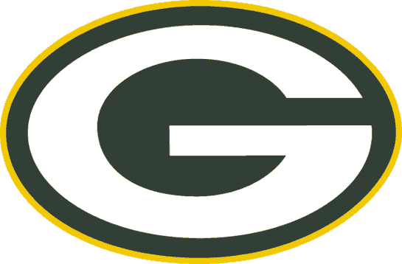
6:30 PM - Eagles vs. Packers
BYE - Falcons

October 16, 2014:
6:30 PM - Packers vs. Falcons
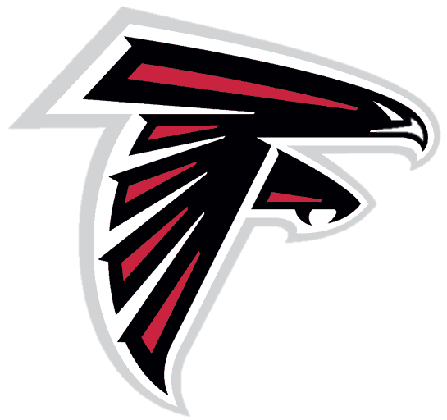
BYE - Eagles
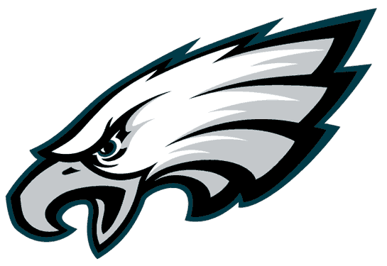
October 23, 2014:
6:30 PM - Falcons vs. Eagles
BYE - Packers

October 30, 2014:
6:30 PM - Packers vs. Eagles
BYE - Falcons

November 6, 2014:
6:30 PM - Falcons vs. Packers
BYE - Eagles

November 10, 2014:
6:30 PM - Eagles vs. Falcons
BYE - Packers

November 13, 2014:
6:30 PM - Eagles vs. Packers
BYE - Falcons

November 17, 2014:
6:30 PM - Packers vs. Falcons
BYE - Eagles

November 20, 2014:
6:30 PM - Falcons vs. Eagles
BYE - Packers

